Tricia Martineau Wagner, a nationally renowned author and presenter, is an experienced elementary teacher and reading specialist. As a well versed and entertaining speaker she brings history to life! Ms. Wagner enjoys conducting classroom presentations for grades K - 8.

“A Child’s Life Out West” hands-on presentation:

The author will:

- Come dressed in a period costume
- Give a brief history of the Oregon Trail (1840s – 1880s)
- Set up 10 interactive stations to visit
- Explain how a book is published
- Share how she gets ideas for her book
- Inspire students to write
- Stress the importance of editing and rewriting their own work
- Bring to life America’s past and excite students to read more about it
- Q & A
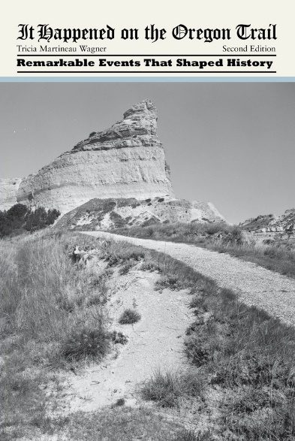

Highlights of school presentation:

- The interactive, hands-on presentation includes 100 pioneer artifacts to handle including a lantern, cooking kettles, wooden buckets, whips, chains, irons, horse shoes, quilts, and a violin.
- Students get to wash clothes, make music, try on period clothing, sew quilts, cook pioneer food, discuss and decide laws for the trail, write with feather pens, make flags, and create old-time decorations.
- Handle tin-type photos of some actual pioneers and view a period video

BOOK SIGNING: Book order forms will be sent home prior to the event. Ms. Wagner will bring the personally autographed books with her to your school. (Late book orders are always accepted.)
An autographed book will be gifted to your school library.

Presentation length: 90 minutes

- Number of presentations in one school visit: 2
- Maximum of 60 students per presentation
- $400 each presentation

Visit Ms. Wagner’s website: www.authortalk.org. For additional information or to schedule an event please contact the author directly: tricia@authortalk.org

Additional program presentations that coordinate with her other books include: 50 Wacky Things Animals Do / North Carolina, the First Golden State / It Happened on the Underground Railroad / It Happened on the Oregon Trail / Black Cowboys of the Old West / African American Women of the Old West.

Thank you in advance for forwarding this educational opportunity to other schools/educators.

